-- Total sales by category in the 'South' region

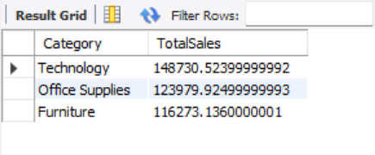

-- Retrieves Order ID, Customer Name, and Sales from the Superstore table

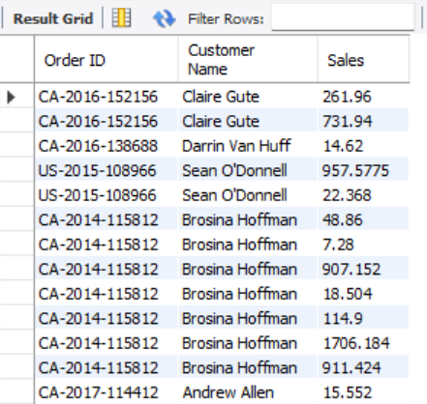

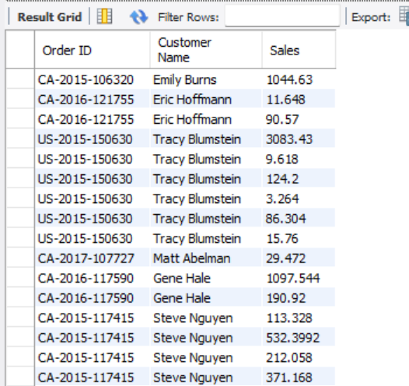

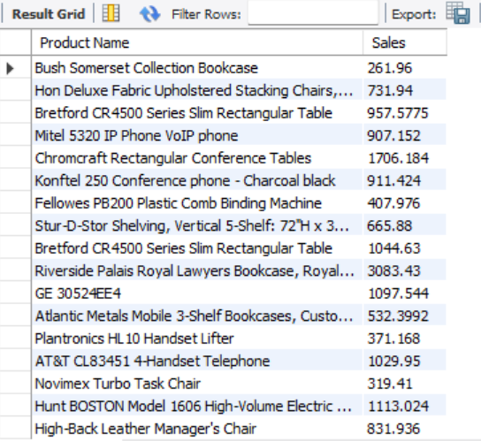

-- Products with sales above average

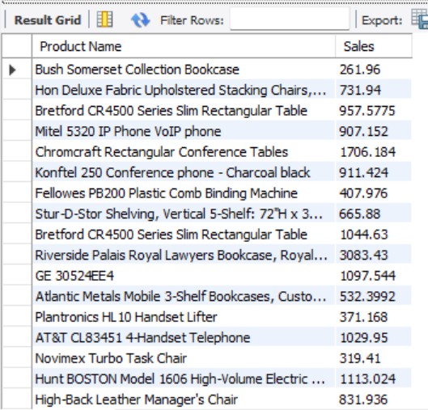

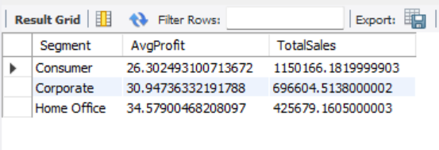 -- Average profit and total sales by segment

-- Create a view for top-selling products



-- Create index on Customer ID and Product ID



-- Shows the 5 products that made the most total profit

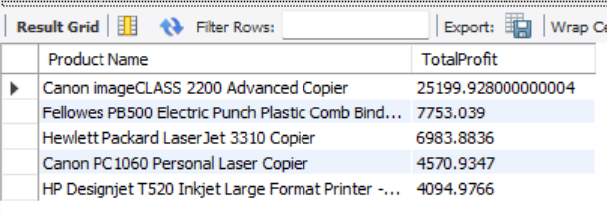

-- Lists all different types of shipping modes used

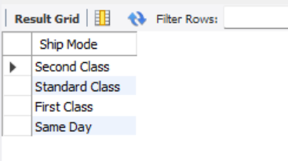

-- Displays total sales per month

